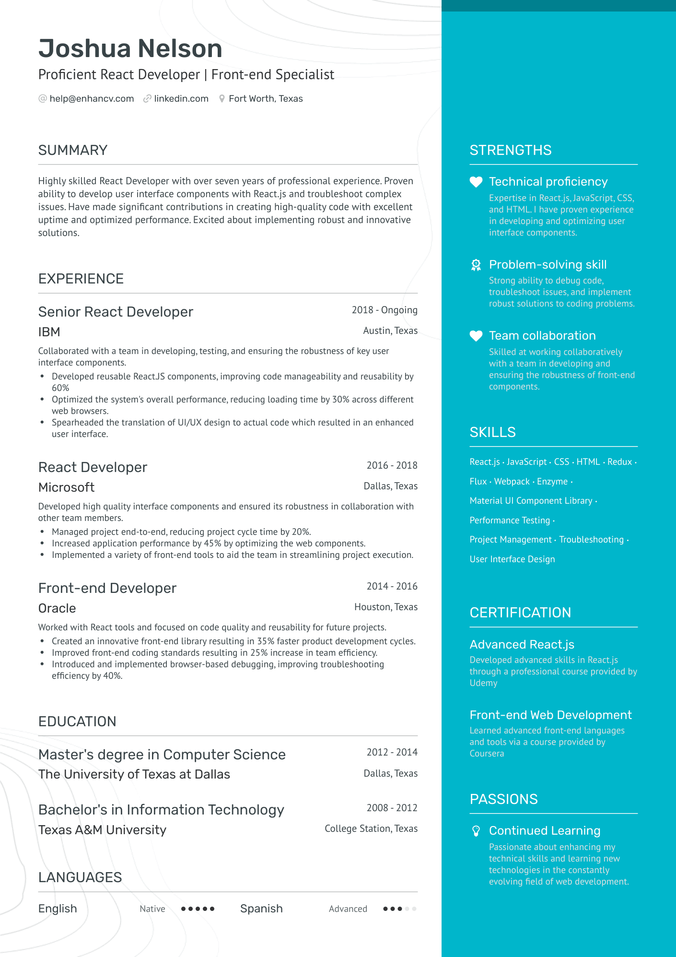
Joshua Nelson
Proficient React Developer | Front-end Specialist @help@enhancv.com linkedin.com Fort Worth, Texas
SUMMARY
Highly skilled React Developer with over seven years of professional experience. Proven ability to develop user interface components with React.js and troubleshoot complex issues. Have made significant contributions in creating high-quality code with excellent uptime and optimized performance. Excited about implementing robust and innovative solutions.
EXPERIENCE
Senior React Developer
2018 - Ongoing
Austin, Texas
IBM
Collaborated with a team in developing, testing, and ensuring the robustness of key user interface components.
·
•
Developed reusable React.JS components, improving code manageability and reusability by 60%
Optimized the system's overall performance, reducing loading time by 30% across different web browsers.
Spearheaded the translation of UI/UX design to actual code which resulted in an enhanced user interface.
React Developer Microsoft
2016-2018
Dallas, Texas
Developed high quality interface components and ensured its robustness in collaboration with other team members.
• Managed project end-to-end, reducing project cycle time by 20%.
•
Increased application performance by 45% by optimizing the web components.
Implemented a variety of front-end tools to aid the team in streamlining project execution.
Front-end Developer
2014-2016
STRENGTHS
Technical proficiency
Expertise in React.js, JavaScript, CSS, and HTML. I have proven experience in developing and optimizing user interface components.
Problem-solving skill Strong ability to debug code, troubleshoot issues, and implement robust solutions to coding problems.
Team collaboration
Skilled at working collaboratively with a team in developing and ensuring the robustness of front-end components.
SKILLS
React.js. JavaScript CSS HTML. Redux . Flux. Webpack. Enzyme.
Material UI Component Library. Performance Testing.
Project Management. Troubleshooting. User Interface Design
Oracle
Houston, Texas
Worked with React tools and focused on code quality and reusability for future projects.
• Created an innovative front-end library resulting in 35% faster product development cycles.
·
Improved front-end coding standards resulting in 25% increase in team efficiency. Introduced and implemented browser-based debugging, improving troubleshooting efficiency by 40%.
EDUCATION
Master's degree in Computer Science The University of Texas at Dallas
2012-2014
Dallas, Texas
CERTIFICATION
Advanced React.js
Developed advanced skills in React.js through a professional course provided by Udemy
Front-end Web Development Learned advanced front-end languages and tools via a course provided by Coursera
Bachelor's in Information Technology
Texas A&M University
LANGUAGES
English
2008-2012
College Station, Texas
PASSIONS
Continued Learning Passionate about enhancing my technical skills and learning new technologies in the constantly evolving field of web development.
Native ..... Spanish
Advanced .....

